COMM 2 LAB REPORT 5

UTKU ACAR / 250206062

**5.1.b)**



Figure 1

As we can see in Figure 1 above, BASK demodulated signal is same with our input bit sequence as it should be.

If we look to the modulated part of BASK, we can see that while input bit sequence equals 1 corresponding part of the modulation becomes equal to Ac*cos(2*pi*fc*t) and when input sequence equals to 0 corresponding part (time interval) of signal becomes 0. The crucial point of this part was keeping record of the time. Because if we don’t keep record of time and start the carrier wave from 0 to sample time again and again, we could be never obtaining some amplitudes of carrier wave. Amplitudes are changing between states because different states represented by different amplitudes.

**5.1.c)**



Figure 2

As we can see in Figure 2 above, BFSK demodulated signal is same with our input bit sequence which is expected.

If we look to the modulated part of BFSK, we can see that while input bit sequence equals 1 corresponding part of the modulation becomes equal to Ac*cos(2*pi*f1*t) and when input sequence equals to 0 corresponding part (time interval) of signal becomes Ac*cos(2*pi*f2*t). While higher frequency carrier wave is representing bit 0, lower frequency carrier wave represents bit 1. Different states represented by different frequency carrier waves as expected.

**5.1.d)**



Figure 3

As we can see in Figure 3 above, BPSK demodulated signal is same with our input bit sequence which is correct.

If we look to the modulated part of BPSK, we can see that while input bit sequence equals 1 corresponding part of the modulation becomes equal to Ac*cos(2*pi*fc*t+2*pi*0/2) and when input sequence equals to 0 corresponding part (time interval) of signal becomes Ac*cos(2*pi*fc*t+2*pi*1/2). While carrier wave with 0-degree phase difference is representing bit 0, carrier wave with 180-degree phase difference represents bit 1. Different states represented by different carrier waves phase differences as expected.

**Report Questions**

**BASK MODULATION**

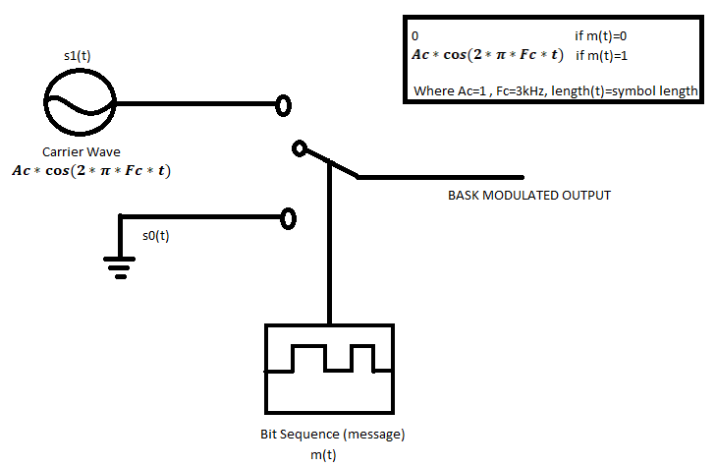

Figure 4

**BFSK MODULATION**

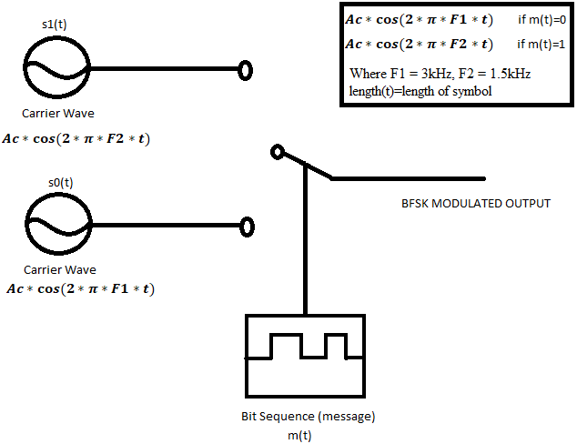

Figure 5

**BPSK MODULATION**

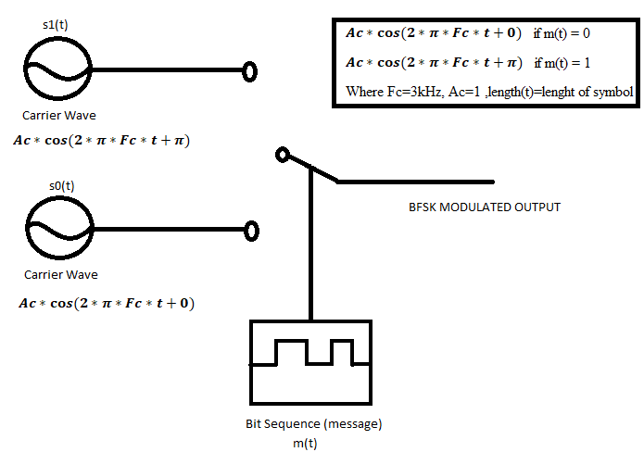

Figure 6

1. In general, we compare how correlated the specific part of the x(t) and corresponding base signals (s0(t), s1(t))

If correlation of specific part of x(t) and s0(t) is higher than correlation with s1(t), it means that our received bit should be equal to the bit 0 since specific part is more like the s0(t) than s1(t).

Sum of correlation of x(t) with s0(t) should be equal to Fs*bit_duration/2 = 45

Sum of correlation of x(t) with s1(t) should be equal to – (Fs*bit_duration/2) = -45

-45-45=-90. Since we have negative number, we choose 0.

Instead of substruction, we could do take maximum value of two summations. Since 45>-45 the bit 0 should be received by us.

**BASK DEMODULATION**

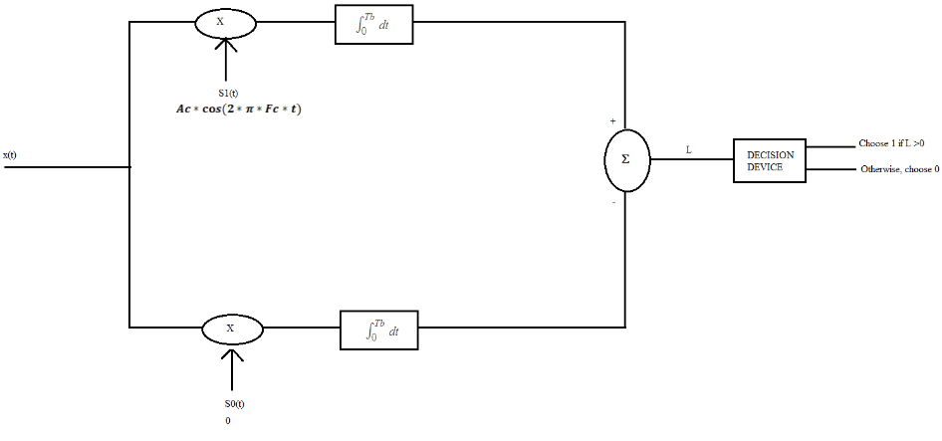

Figure 7

**BFSK DEMODULATION**

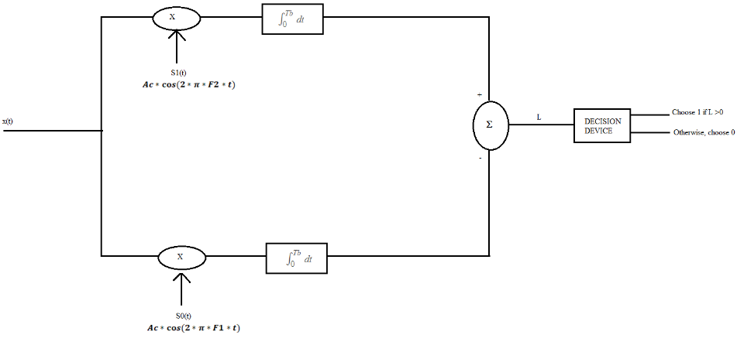

Figure 8

**BPSK DEMODULATION**

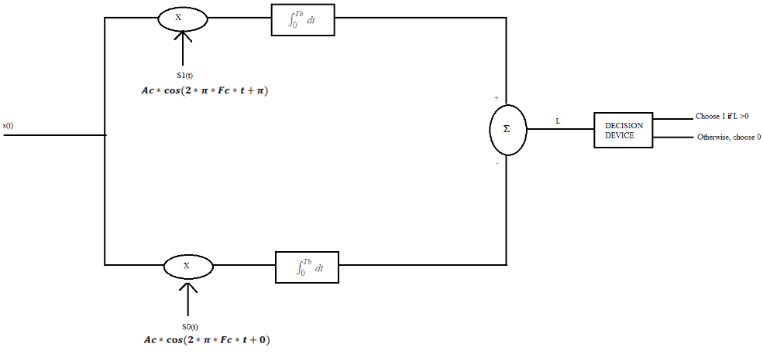

Figure 9

1. While we are using BASK modulation, we represent different bits with changing amplitudes without changing phase or frequency, in BFSK modulation these different bits represented by changing frequency of carrier signal without changing amplitude or phase, in BPSK modulation we represent different bits by changing phase of the carrier signal without changing amplitude or frequency.